

**Air Quality and Water Quality estimation**

**A Project Report Submitted to the**

**Walchand Institute of Technology, Solapur an Autonomous Institute affiliated to**

**PAH Solapur University, Solapur**

**For the Mini Hardware Project in Electronics**

**&Telecommunication Engineering**

**By**

1. Mr. Suyash Sumant Roll No: A-40
2. Mrs. Samiksha Mane Roll No: A-26
3. Mrs. Shweta Patil Roll No: A-29

T.Y (Electronics and Telecommunication)

*A.Y. 2023-24 Semester Ⅵ*

Department of Electronics & Telecommunication Engineering

**CERTIFICATE**

This is to certify that Mini Project entitled

**Air Quality and Water Quality Estimation**

Submitted by

**Name** **Roll No.**

Suyash Sumant A-40

Samiksha Mane A-26

Shweta Patil A-29

has been approved as the partial fulfilment for the award of Third- year of Electronics and Telecommunication Engineering by **Walchand Institute of Technology an Autonomous Institute affiliated to PAH Solapur University**, Solapur in the academic year 2023-24.

**Asst.Prof.** **Venkatesh Mylavarpu Dr. Asha Thalange**

Project Guide Head, E&TC Department

**Dr. V.A. Athavale** PRINCIPAL

DEPARTMENT OF ELECTRONICS AND TELECOMMUNICATION ENGINEERING WALCHAND INSTITUTE OF TECHNOLOGY, SOLAPUR, 2023-2024

# ACKNOWLEDGEMENT

The project has certainly enlightened us with the modern era of Technologies and it has boosted our confidence. The project work has certainly rendered us tremendous learning as well as practical experience.

We are thankful to **Dr. V. A. Athavale**, Principal of W.I.T College, **Dr. A. V Thalange** Head of Electronics & Telecommunication Engineering Department for granting permission to undertake this project.

We are very grateful to **Prof. V Mylavarpu** for their valuable guidance about hardware implementation and programming.

At last, but not least we are thankful to staff of Electronics & Telecommunication Engineering Department W.I.T. Solapur.

**INDEX**

|  |  |  |
| --- | --- | --- |
| **SR NO.** | **CONTENTS** | **PAGE NO.** |
|  | Abstract | 5 |
| 1 | Introduction | 6 |
| 2 | Literature Review | 7 |
| 3 | Working of Components | 8 |
| 3.1 | Working Principle | 14 |
| 3.2 | Advantages and Disadvantages | 15 |
| 3.3 | Applications | 16 |
| 4 | Conclusion | 17 |
| 5 | Future Scope | 18 |
|  | References | 20 |

**ABSTRACT**

This project presents a real-time air and water quality monitoring system utilizing ESP8266 Wi-Fi module, Arduino Uno microcontroller, and an array of environmental sensors. The system leverages the ESP8266's wireless capabilities for seamless data transmission, while the Arduino Uno acts as the central processing unit.

For air quality monitoring, the project employs an MQ-135 sensor, known for its detection of volatile organic compounds (VOCs) commonly found in air pollution. Additionally, a DHT11 sensor is incorporated to measure temperature and humidity, which can influence air quality.

Water quality analysis is achieved through a pH sensor for gauging acidity levels and a turbidity sensor for detecting suspended particles. These parameters are crucial for assessing water potability and overall health.

The collected air and water quality data are expected to be transmitted wirelessly through the ESP8266, enabling remote monitoring and real-time data visualization. This system holds potential applications in environmental monitoring, precision agriculture, and smart homes, promoting a data-driven approach to environmental health.

1. **INTRODUCTION**

Fresh air and clean water are essential for a healthy life. However, with increasing urbanization and industrialization, maintaining good air and water quality is becoming a growing challenge. This project presents a cost-effective and efficient air and water quality monitoring system designed to track key environmental parameters.

The system utilizes a combination of powerful hardware components:

* **ESP8266:** This versatile Wi-Fi module enables wireless communication, allowing the system to transmit collected data to a central server or cloud platform for real-time monitoring and analysis.
* **Arduino Uno:** This popular microcontroller serves as the central processing unit, coordinating sensor data collection, processing, and communication with the ESP8266.

The system leverages a range of sensors to measure crucial environmental indicators:

* **pH Sensor:** Measures the acidity or alkalinity of water, a critical factor for aquatic life and drinking water safety.
* **Turbidity Sensor:** Detects the presence of suspended particles in water, indicating potential contamination levels.
* **DHT11 Sensor:** Monitors air temperature and humidity, which can influence air quality and pollution levels.
* **MQ-135 Sensor:** Detects volatile organic compounds (VOCs) in the air, often associated with industrial emissions and hazardous materials.

By combining these components, this project aims to provide a comprehensive and user-friendly solution for monitoring air and water quality. The collected data can be used for various purposes, including:

* **Environmental awareness**
* **Pollution detection**
* **Decision-making**

This project contributes to a more sustainable future by promoting environmental monitoring and encouraging responsible practices for cleaner air and water.

1. **LITERATUR REVIEW**

**Air Quality Monitoring**

* **Arduino and MQ-135 Sensor:** Studies demonstrate the effectiveness of Arduino coupled with the MQ-135 sensor for monitoring air quality, particularly volatile organic compounds (VOCs) . Real-time data transmission using Wi-Fi modules allows for remote monitoring and analysis.
* **IoT-based Air Quality Monitoring:** Research highlights the potential of the Internet of Things (IoT) for air quality monitoring. By integrating Arduino with sensors and cloud platforms, researchers achieve real-time data collection, visualization, and potential alerts for exceeding pollution levels .

**Water Quality Monitoring**

* **Multi-Sensor Systems for Water Quality:** Several studies showcase the use of Arduino with sensors like pH, turbidity, and conductivity to monitor various water quality parameters. These systems effectively assess water quality through continuous monitoring and data transmission.
* **Turbidity Sensor and Arduino:** Research underlines the significance of the turbidity sensor for water quality measurement. By detecting suspended particles, this sensor helps determine potential contamination levels in water.

**Integration of Arduino, ESP8266, and Sensors**

* **Air Quality Monitoring and Alert System:** Studies showcase the successful combination of Arduino with ESP8266 Wi-Fi modules for air quality monitoring. The ESP8266 enables data transmission to cloud platforms, facilitating remote access and analysis of air quality data.

**Key Findings and Considerations**

The reviewed literature highlights the strengths of using Arduino, ESP8266, and various sensors for air and water quality monitoring.

These systems offer:

* **Cost-effectiveness:** They provide a relatively affordable solution compared to traditional monitoring systems.
* **Real-time monitoring:** The systems enable continuous data collection and transmission, allowing for real-time insights into environmental conditions.

# 3.WORKING OF COMPONENTS

## ARDUINO UNO:

The Arduino UNO is a programmable, open-source from the Arduino series. It contains an ATMega328P microcontroller from Atmel with an 8-bit RISC processing core and 32 KB of flash memory. The board can be powered from a voltage range of 7 to 12 volts, the voltage regulator embedded inside the board will reduce the excess voltage.

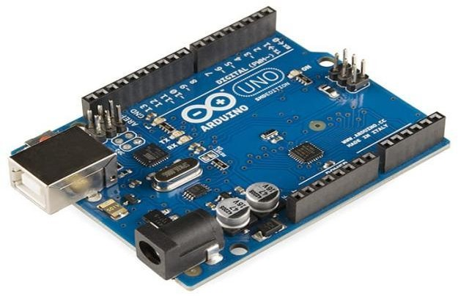

**ESP8266:**

The ESP8266 is a low-cost, Wi-Fi microchip with built-in TCP/IP networking software and microcontroller capability. It is a popular choice for Internet of Things (IoT) applications due to its small size, low power consumption, and ease of use.

ESP8266 chip

The ESP8266 is a complete Wi-Fi solution that includes a microcontroller, memory, and a Wi-Fi transceiver. This means that you can connect the ESP8266 to your Wi-Fi network and start communicating with the internet immediately.

The ESP8266 can be programmed using a variety of programming languages, including C++, Arduino, and Lua. There are also a number of development boards available that make it easy to get started with the ESP8266.

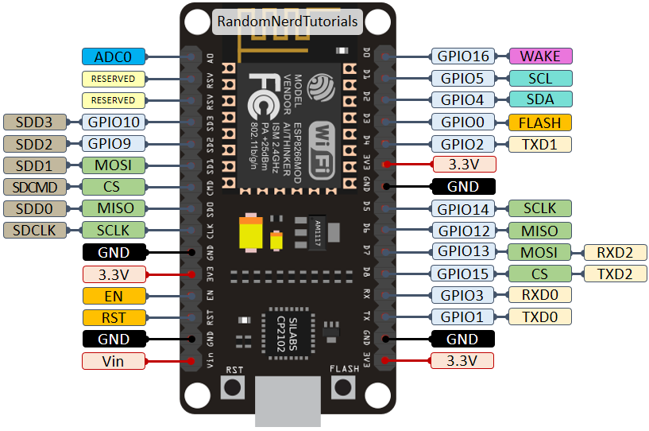

**MQ-135:**

The MQ-135 sensor detects gas by utilizing a change in electrical resistance. Here's a breakdown of its working principle:

1. **Sensing element:** The core of the sensor is a tin dioxide (SnO2) semiconductor layer. In clean air, this layer offers high resistance.
2. **Heating element:** The sensor also has a built-in heating element that maintains an elevated temperature for optimal operation.
3. **Gas interaction:** When target gases (like ammonia, alcohol, or smoke) come in contact with the heated SnO2 layer, an interesting phenomenon occurs.
4. **Conductivity change:** The target gas molecules interact with the SnO2 layer, causing an increase in the number of free electrons. This phenomenon drastically reduces the resistance of the SnO2 layer.
5. **Resistance variation and output signal:** The change in resistance of the SnO2 layer due to the presence of gas molecules is directly correlated with the gas concentration. This variation in resistance is the sensor's output signal.

By measuring this electrical resistance change, we can estimate the presence and concentration of target gases in the surrounding environment.

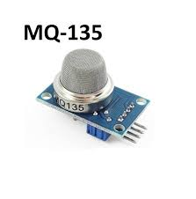

## DHT11:

The DHT11 sensor is a popular choice for measuring both temperature and humidity. Here's a breakdown of how it works:

**Sensing Elements:**

* **Capacitive Humidity Sensor:** This part consists of two electrodes with a moisture-holding material between them. As humidity levels change, the capacitance (ability to store electrical charge) of this material also changes.
* **Thermistor:** This is a temperature-dependent resistor. The resistance of the thermistor decreases with increasing temperature (Negative Temperature Coefficient or NTC).

**Data Acquisition:**

1. **Initiation:** The DHT11 sensor requires a specific signal from a microcontroller to initiate a measurement cycle.
2. **Humidity Sensing:** The sensor measures the capacitance of the humidity sensing element, which reflects the current humidity level.
3. **Temperature Sensing:** The thermistor's resistance is measured, which corresponds to the surrounding temperature.
4. **Digital Conversion:** The DHT11's internal circuitry converts the analogue measurements (capacitance and resistance) from the humidity sensor and thermistor into digital data.

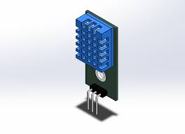

**Turbidity Sensor:**

* Measurement of Turbidity: Detects the cloudiness or haziness of a liquid caused by suspended particles.
* Principle of Operation: Utilizes light scattering or absorption to quantify the turbidity of a fluid.

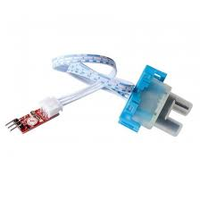

**pH Sensor (4502C pH sensor):**

* **pH Measurement**: Measures acidity or alkalinity of solutions.
* **Interfacing**: Can be interfaced with microcontrollers like Arduino.
* **Versatility**: Suitable for various pH monitoring applications.

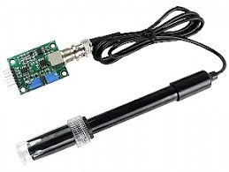

**3.1 Working principle**

This system combines Arduino Uno, ESP8266, and several sensors to monitor air and water quality. Here's a breakdown of the working principle:

**System Components**:

* Microcontroller (Arduino Uno): The central processing unit that reads sensor data, processes it, and prepares it for transmission.
* Wi-Fi Module (ESP8266): Enables the system to connect to a Wi-Fi network and transmit collected data to a server or cloud platform for storage and visualization.
* Sensors:
  + DHT11: Measures temperature and humidity of the surrounding air.
  + MQ-135: Detects various gases like ammonia, alcohol, and smoke, indicating overall air quality.
  + pH Sensor: Measures the acidity or alkalinity of water.
  + Turbidity Sensor: Measures the amount of suspended particles in water, indicating its clarity.

**Working Principle**:

1. Sensor Data Acquisition:
   * The Arduino Uno reads data from each sensor at regular intervals.
   * DHT11 requires a specific signal to initiate a measurement cycle, returning both temperature and humidity data.
   * MQ-135 provides an analog voltage output based on the gas concentration. This needs conversion to a usable value using a calibration factor.
   * pH and turbidity sensors typically have analog outputs that the Arduino reads directly.
2. Data Processing:
   * The Arduino code processes the raw sensor data based on sensor-specific calibration factors or formulas to convert them into meaningful units (e.g., temperature in °C, gas

concentration in ppm, pH level, turbidity in NTU).

1. Data Transmission (using ESP8266):
   * The processed data is sent from the Arduino to the ESP8266 module.
   * The ESP8266 connects to a pre-configured Wi-Fi network using its credentials stored in the Arduino code.

## 3.1 ADVANTAGES AND DISADVANTAGES OF THE PROJECT:

## Advantages of the Air and Water Quality Monitoring System with Arduino, ESP8266, and Various Sensors:

* **Cost-effective:** This system utilizes readily available and relatively inexpensive components like Arduino Uno and ESP8266, making it accessible for DIY projects and budget-conscious applications.
* **Scalability:** The system can be easily scaled up or down by adding or removing sensors depending on the specific needs of the monitoring project. You can tailor it to monitor a wider range of parameters by incorporating additional sensors.
* **Open-source and Customizable:** The Arduino platform and many sensor libraries are open-source, allowing for customization and adaptation to specific requirements. You can modify the code to suit your data analysis needs and desired outputs.
* **Real-time Monitoring:** The system provides real-time data on air and water quality, enabling immediate response to any fluctuations or potential issues.
* **Data Logging and Visualization:** Collected data can be logged and visualized on a server or cloud platform, allowing for historical analysis and identification of trends.
* **Alerting System (Optional):** Alerts can be set up to notify users when air or water quality parameters exceed predefined thresholds, enabling prompt action to address potential problems.

## Disadvantages of the System:

* **Limited Accuracy:** While suitable for many applications, some sensors like the MQ-135 may have limitations in

accuracy compared to high-end industrial sensors.

* Calibration might be necessary to maintain acceptable accuracy levels.
* **DIY Complexity:** Setting up and programming the system requires some technical knowledge of Arduino, sensor libraries, and potentially Wi-Fi communication protocols. Pre-built solutions might be easier for those

without technical expertise.

* **Data Security Considerations:** Security measures need to be implemented on the ESP8266 and server-side to ensure data privacy during transmission and storage, especially if the system monitors sensitive environments.
* **Power Consumption:** Continuous operation requires a reliable power source. Battery life can be a concern for portable applications, and power consumption needs to be factored in for permanent setups.
* **Maintenance:** Regular maintenance, including sensor calibration and system checks, is necessary to ensure the system's ongoing accuracy and reliability.

**Overall, this air and water quality monitoring system offers a cost-effective and customizable solution for various applications. However, it's important to consider the limitations in accuracy and the technical expertise required for setup and maintenance.**

## 3.2 APPLICATIONS

The air and water quality monitoring system you described with Arduino Uno, ESP8266, and various sensors can be applied in a variety of settings. Here are some specific examples:

**1. Smart Homes and Buildings:**

* **Indoor Air Quality Monitoring:** Track temperature, humidity, and gas levels (like CO2 or VOCs) to ensure a healthy and comfortable living environment. Trigger alerts if ventilation is needed or if harmful gas concentrations become too high.
* **Water Quality Monitoring:** Monitor water quality in domestic water supplies. This can be helpful for well water systems or areas with concerns about lead or other contaminants. Alert homeowners if the pH level falls outside the acceptable range or if turbidity increases significantly.
* **Leak Detection:** Integrate water sensors with the system to detect potential leaks early on, preventing water damage and mold growth.

**2. Precision Agriculture**

* **Greenhouse Monitoring:** Monitor temperature, humidity, and CO2 levels in greenhouses to optimize plant growth. The system can automate ventilation and irrigation systems based on real-time sensor data.
* **Soil Moisture Monitoring:** Track soil moisture levels to ensure optimal water usage for crops. This can help farmers conserve water and improve crop yields.
* **Nutrient Monitoring (Optional):** With additional sensors, you can monitor nutrient levels in soil or water runoff to optimize fertilization strategies.

**3. Environmental Monitoring**

* **Outdoor Air Quality Monitoring:** Deploy the system in public areas or industrial zones to track air quality. This data can be used to identify pollution sources and take appropriate actions.
* **Water Quality Monitoring in Rivers and Lakes:** Monitor water quality in natural water bodies to track pollution levels and ecosystem health. This data can be used by environmental agencies

to regulate industries and protect water resources.

* **Early Warning Systems for Natural Disasters:** The system can be integrated with rain gauges or flood sensors to provide early warnings for potential floods or landslides.

**4. Industrial Applications**

* **Industrial Process Monitoring:** Monitor air quality in factories to ensure

worker safety and compliance with environmental regulations. The system can detect leaks of hazardous gases and trigger alarms or ventilation systems.

* **Wastewater Treatment Monitoring:** Track pH, turbidity, and other parameters in wastewater treatment plants to optimize the treatment process and ensure proper effluent quality.
* **Building Automation:** Integrate the system with building automation systems to adjust ventilation rates, lighting, and other parameters based on real-time air quality data.

## CONCLUSION

This project has demonstrated the design and functionality of an air and water quality monitoring system using Arduino Uno, ESP8266, and various sensors. The system offers real-time data acquisition on temperature, humidity, gas concentration, pH, and turbidity, enabling effective monitoring of air and water quality in a variety of environments.

The key strengths of this system lie in its cost-effectiveness, scalability, and open-source nature. It can be customized with additional sensors to suit specific monitoring needs. Real-time data with optional alerts allows for prompt intervention when air or water quality parameters fall outside acceptable ranges.

However, limitations like sensor accuracy and the requirement for technical expertise in setup and maintenance need to be considered.

Overall, this project provides a valuable foundation for building a user-friendly and adaptable air and water quality monitoring system for various applications. With further development and integration with cloud platforms or data analysis tools, the system's potential for environmental monitoring, resource management, and data-driven decision making can be significantly enhanced.

## FUTURE SCOPE

The air and water quality monitoring system we've built with Arduino, ESP8266, and various sensors has a promising future scope for further development and expanded functionalities. Here are some exciting possibilities:

**1. Advanced Sensor Integration:**

* **Sensor Fusion:** Integrate additional sensors to monitor a wider range of parameters. For example, consider sensors for detecting specific pollutants (e.g., NO2, SO2), measuring wind speed/direction, or monitoring for harmful algal blooms in water bodies.
* **Bio-sensor Integration:** Explore the potential of biosensors for real-time monitoring of biological contaminants or toxicity levels in water.

**2. Enhanced Data Analysis and Communication:**

* **Machine Learning Integration:** Utilize machine learning algorithms to analyse sensor data and identify patterns or predict potential issues. This can lead to more proactive maintenance and preventive actions.
* **Improved Data Visualization:** Develop more sophisticated data visualization tools to present collected information in a user-friendly and informative way. This could involve interactive dashboards or real-time maps for wider accessibility.
* **Advanced Communication Protocols:** Explore communication protocols beyond Wi-Fi, such as cellular networks or Low Power Wide Area Networks (LPWAN) for wider range and remote monitoring capabilities.

**3. System Miniaturization and Power Optimization:**

* **Miniaturized Components:** As technology advances, explore the use of smaller and more energy-efficient versions of Arduino boards and sensors for creating compact and portable monitoring systems.

cycling techniques to reduce power consumption and extend battery.

* **Low-Power Operation Strategies:** Implement sleep modes or duty life for portable applications. Consider incorporating energy harvesting techniques like solar panels for self-powered systems.

**4. Cloud Integration and Citizen Science Applications:**

* **Cloud-based Data Storage and Management:** Utilize cloud platforms for secure data storage, real-time data access, and remote system management. This allows for wider collaboration and data sharing.
* **Citizen Science Applications:** Develop a user-friendly interface for the system, enabling citizen participation in data collection and environmental monitoring projects. This can contribute to valuable community-based datasets.

**5. Integration with Building Management Systems (BMS):**

* **Smart Building Integration:** For indoor air and water quality monitoring, explore seamless integration with Building Management Systems (BMS) for automated adjustments of ventilation, air filtration, or water treatment systems based on real-time sensor data.

By incorporating these advancements, your air and water quality monitoring system can evolve into a powerful tool for environmental monitoring, resource management, and promoting environmental awareness. It can contribute to creating healthier living spaces, optimizing resource usage, and fostering citizen science initiatives for a more sustainable future.

## REFERENCES

1. [https://www.instructables.com/Bi-Directional-Visitor-Counter-](https://www.instructables.com/Bi-Directional-Visitor-Counter-Using-Single-Ultras/) Using-Single-Ultras/
2. The complete guide for Arduino microcontroller [https://www.arduino.cc/reference/en/.](https://www.arduino.cc/reference/en/)
3. Arduino: The Ultimate Guide to Arduino Programming by Massimo Banzi and Michael Margoniner. This book provides a comprehensive overview of Arduino programming, including how to use ultrasonic sensors and LCD displays.